|  |
| --- |
| CS590BD Big Data Analytics and Applications |
| Lab 4 Assignment |
| Goutham Marikanti  16171450 |

TASK 1

# Provide a Save File option once you invoke the HBASE Retrieval operation

Once we click the ‘Retrieve’ button, the file is saved to our system as it was saved in Lab2.

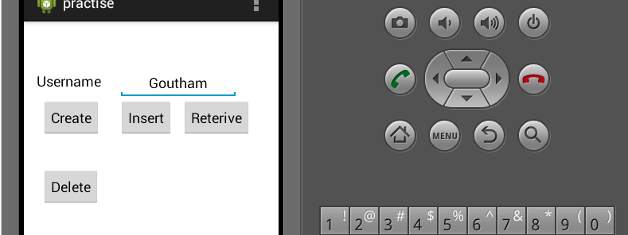

* Created four training files and saved to our device.
* Save the files on to Cloudera.
* Now we convert the text files into sequence files by calling the given service.

[http://134.193.136.147:8080/HMMWS/jaxrs/generic/TrainFileOperation/-home-group6-LeftToRightJ.txt/-home-group6-leftrightj.seq](http://134.193.136.147:8080/HMMWS/jaxrs/generic/TrainFileOperation/-home-group6-LeftToRightJ.txt/-home-group6-leftrightj.seq%20%20)

* Left to Right.seq

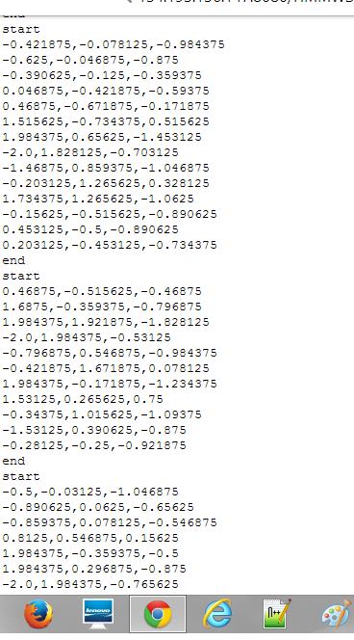

* Right to left sequence



* Bottom to top sequence

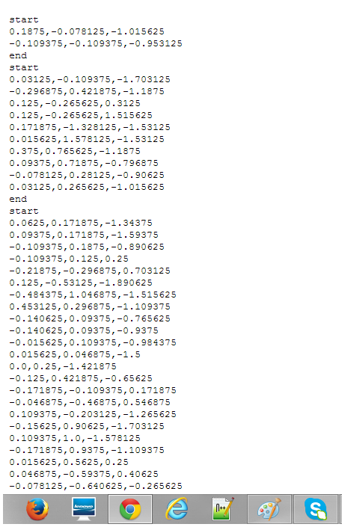

* Test File Sequence

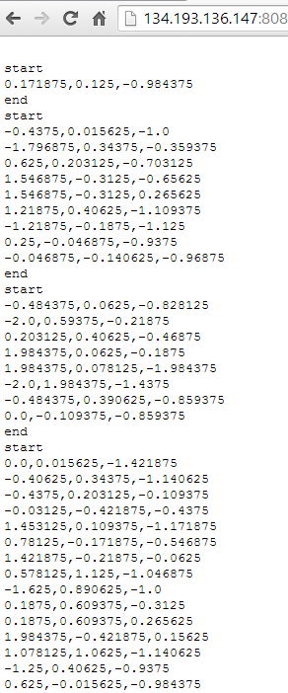

* Training and testing for activity recognition

As we have set of sequence files for training and testing, now we have to run below service using our generated sequence files to identify whether training got success and generates motions.

[http://134.193.136.127:8080/HMMWS/jaxrs/generic/HMMTrainingTest/-home-group6-leftrightj.seq/-home-group6-RightToLeft.seq/-home-group6-BTPJ.seq/-home-group6-TestFilej.seq](http://134.193.136.127:8080/HMMWS/jaxrs/generic/HMMTrainingTest/-home-group6-leftrightj.seq/-home-group6-RightToLeft.seq/-home-group6-BTPJ.seq/-home-group6-TestFilej.seq%20%20)